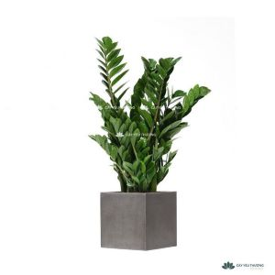

Scientific name: Zamioculcas zamiifolia (kim tiền )

LIGHT:

Low to bright indirect light, such as from a north-, east-, or west-facing window. Avoid direct sunlight, which can scorch the leaves. No windows? No problem. ZZ plant also grows well under fluorescent lighting.

.

WATERING:

One of the rare ways you can kill a ZZ plant is by overwatering. During the active growing season (spring through early fall), only water every two weeks or when the top inch or two of soil feels dry. Water less frequently during the winter months or if growing your plant under low-light conditions.

SOIL:

Use a well-draining potting mix that includes perlite

FERTILIZING:

Because ZZ plants can store nutrients in their roots, they don’t need frequent fertilization. Feed every month or so during spring and summer using an all-purpose houseplant fertilizer diluted to half the recommended rate. Do not fertilize in winter.

### Temperature and Humidity:

Indoors, grow at average room temperatures of 60 to 75 degrees F. If you put your plant outdoors during the summer, be sure to bring it back inside if temperatures fall below 50 degrees F.